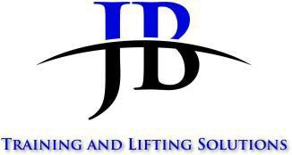
CSCS Booking Form

Please complete and return by email to info@jbtraining.co.uk. Once we have received the booking form, we will send joining instructions.

The H&S Test will not be confirmed until this form has been completed and returned to us.

*for office use only
Test Title: | Accreditation type: CSCS
Test Dates: TBA | Test Time: TBA
Name of Person Booking: | Test Cost: Health & Safety - £40 plus VAT  Skills Tests - £80 plus VAT

Booking Details:
Title: Mr ☐ Mrs ☐ Ms ☐ Miss ☐ Other ☒
Name (person booking): | Contact Number:
Company Name and Address
Email:
CITB Levy Number:
Candidate Full Name:
Address:

Date of Birth:

NI No:
Test Type (Please Circle): MAPs - Supervisor – Operatives (Plant Ops / Slinger) Skills Test: RT61 – RT62 – RT40 – RT60 – Please any other Skills Test RT ?
Training centre address including postcode: | JB Training and Lifting Solutions Unit 17, E- Net Park Mill Road Industrial Estate Linlithgow  EH49 7DA 01506  813768

Health and Reasonable adjustments

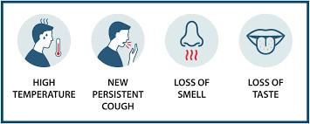
Please keep JB Training advised if any candidates that may need additional support or has any medical conditions, we should be aware off?
Please ensure that any candidates attending any training courses to following Government Guidelines regarding COVID 19.
If any candidates are showing/ feeling any COVID symptoms, please contact our office to rearrange attendance to a future course as soon as possible

Payment Details:
Please ensure payment is made to this account by BACS.

JB Training and Lifting Solutions Ltd
Sort Code: 80-22-60
Account Number 06599489
Clients Details

Account Department Details:
Tel No.:
Purchase order no.:
Please note by checking the box you are agreeing to our Terms & Conditions of Sale.

☒ I confirm that I have checked the information on this form, and it is correct.
I declare that I have read, understood, and agree to JB Training and Lifting Solutions Ltd terms and conditions which can be viewed below.

Terms and Conditions of Sale

Test Fees
Fees quoted are exclusive of Value-added Tax (VAT) which will be included at the current rate.

Bookings
The test dates provided are reserved only and not confirmed until receipt confirmation has been received.
Bookings can be made by email or telephone, but details must be provided to enable the booking of any candidates on any CSCS Test.
These details are listed on the first page (Candidates details).
Candidates must arrive at least 15 minutes before test time and bring the required Identification. Late arrivals may be refused entry and will be charged.
Candidates without Identification listed on the next page will not be admitted and will be charged.

Please note. Unfortunately, tests may be cancelled or rescheduled due to unforeseen circumstances at any time. JB Training will try to inform you as soon as possible if these circumstances arise.

Payment Terms
Our standard payment terms are that payment is taken at the time of booking.

Cancellations

Should circumstances mean that you need to cancel your test a 48hr notice must be provided for rescheduling.

5 Guidelines for Candidates and Employers
It is your responsibility to ensure that you or your candidates are free from any condition which could affect /their capability to undertake their chosen test. We welcome candidates with disabilities, but it remains their employer’s duty to ensure that they are appropriately supported in their place of work. JB Training and Lifting Solutions Ltd will not be responsible for costs incurred, should it be found at course commencement that a candidate is found not to meet the test eligibility and/or Awarding Bodies requirements.

